

VisionGuard: AI-Assisted Visibility Enhancement and Incident Retrieval for Smart CCTV Surveillance
Final Report
SE - 801 - Software Project Lab III

Submitted By:
Shahid-E-Kaiser Md. Tashrif | BSSE-1448

Supervised By: Dr. Sumon Ahmed Associate Professor
Institute of Information Technology University of Dhaka

Submitted On: October 10, 2026


Letter of Transmittal
October 10, 2026
BSSE 4th Year Exam Committee Institute of Information Technology University of Dhaka

Subject: Final Report Submission, VisionGuard: AI-Assisted Visibility Enhancement and Incident Retrieval for smart CCTV surveillance

Sir,
I am submitting the final report for our Software Project Lab 3, “VisionGuard: AI-Assisted Visibility Enhancement and Incident Retrieval for Smart CCTV Surveillance”. This report comprehensively covers the project's technical details, including design, implementation and testing phases. While I have tried to do my best, I welcome your feedback for improvement.
Thank you for your kind consideration.

Sincerely,
Shahid-E-Kaiser Md. Tashrif
BSSE 1448
Institute of Information Technology University of Dhaka

10.10.2026

Supervisor’s Signature
Acknowledgement
I would like to thank my supervisor, Dr. Sumon Ahmed, for the guidance and feedback provided throughout the development of VisionGuard AI. Their input on scoping the hybrid dehazing architecture and on keeping the system CPU-friendly and explainable has directly shaped the design decisions documented in this report.
Abstract
VisionGuard AI is a lightweight, CPU-friendly CCTV surveillance platform that restores visibility in hazy or smoggy footage in real time. Rather than relying on an end-to-end deep learning model, it uses a hybrid approach: the Dark Channel Prior (DCP) produces a physics-based estimate of a scene's transmission map, and a small refinement CNN corrects that estimate before the clean image is reconstructed through the atmospheric scattering model. The system's central optimization is region-of-interest (ROI) processing, dehazing runs only on the portion of a frame flagged by motion detection, rather than on every pixel of every frame, which keeps the pipeline fast enough for real-time use on ordinary CPU hardware and suitable for edge deployment without a GPU. Beyond the dehazing pipeline itself, VisionGuard AI supports live webcam and IP camera feeds as well as uploaded video files, automatically logs every enhanced event with its timestamp, snapshot, and region coordinates, and lets operators review that history through both a chronological timeline and a natural-language search interface backed by a large language model through OpenRouter. Access is restricted to admin-seeded operator accounts authenticated with JWTs, with no open self-registration. The target users are security guards and surveillance operators in settings such as campuses, warehouses, and parking lots, where hazy conditions can otherwise leave footage unusable exactly when it matters most.
Table of Contents

Project Overview

Project Title
VisionGuard: AI-Assisted Visibility Enhancement and Incident Retrieval for Smart CCTV Surveillance

Problem Statement
CCTV footage from surveillance cameras degrades sharply in haze, smog, and fog, which is exactly when security teams need it most. Visibility loss during these conditions can hide intrusions, accidents, and other events a surveillance system exists to catch. Modern image dehazing research has moved toward end-to-end deep learning models that produce strong results, but those models are typically too heavy to run on the CPU-only hardware found in most guard rooms and edge installations, and running full-frame enhancement on every frame of a live feed is wasteful when most of a frame is static background with nothing happening in it. VisionGuard addresses this by combining a physics-based dehazing model (the Dark Channel Prior) with a lightweight CNN that only refines the prior's transmission estimate, and by restricting all of that computation to the small region of a frame where motion was actually detected and keeping the system real-time, explainable, and deployable without a GPU.

Objectives
- Recover clear visibility in hazy or smoggy CCTV footage without requiring specialized hardware.
- Keep the dehazing pipeline CPU-friendly and capable of real-time (30 FPS target) operation by only processing regions flagged by motion detection, not entire frames.
- Preserve a hybrid, explainable architecture — physics prior (DCP) plus a lightweight CNN refinement — rather than an opaque end-to-end deep learning model.
- Automatically log every enhanced event (timestamp, snapshot, event type, ROI coordinates) so operators have a retrievable record without manual effort.
- Let operators retrieve past events through both a chronological timeline and a natural-language search interface.
- Restrict system access to authenticated operator and administrator accounts, with no open self-registration.

Scope

In scope (MVP):
- Live webcam / IP camera feed ingestion, plus uploaded video file processing.
- Motion detection that skips dehazing entirely when no motion is present.
- ROI extraction from the motion mask, so only the suspicious region is processed.
- The hybrid DCP + Tiny CNN dehazing pipeline (dark channel, Top-K atmospheric light, coarse transmission, CNN refinement, radiance recovery, gamma correction, merge back into frame).
- Event logging with timestamp, snapshot image, event type, and ROI coordinates.
- A timeline / event browser for chronological review.
- Natural language event search (e.g. "any motion last night?") backed by a large language model through OpenRouter.
- JWT-based authentication with admin-seeded accounts (no open signup).

Out of scope (future work, not implemented):
- Object detection / intrusion classification.
- ONNX Runtime inference.
- FFmpeg integration.
- Multi-camera support.
- Temporal transmission smoothing across frames.

Deliverables
- A FastAPI backend implementing the motion-gated, ROI-based hybrid dehazing pipeline.
- A trained Tiny CNN transmission-refinement model with saved weights (backend/weights/tiny_cnn.pth).
- A PostgreSQL-backed event store with repository-layer access for cameras/video sources and events.
- A JWT authentication system with admin-seeded accounts and operator account management.
- A React + TypeScript dashboard for live feed viewing, event timeline browsing, and natural-language event search.
- A preliminary automated test suite covering the dark channel, transmission estimation, CNN inference, motion detection, and ROI extraction modules.

Requirements Analysis

Functional Requirements
- FR-1: The system will allow an operator to start a live feed from a saved webcam or IP camera, or to upload a recorded video file for processing. Several cameras can run at the same time and are started and stopped independently of each other.
- FR-2: The system will allow an operator to stop an active feed at any time and to view the latest processed frame (with the detected region marked) while a feed is running.
- FR-3: The system will continuously monitor incoming frames for motion and skip the dehazing pipeline entirely when no motion is detected.
- FR-4: When motion is detected, the system will extract only the region of interest (ROI) containing that motion rather than processing the full frame.
- FR-5: The system will dehaze the extracted ROI using the Dark Channel Prior for an initial transmission estimate, refine that estimate with a Tiny CNN, and reconstruct the clean region via the atmospheric scattering model before merging it back into the original frame.
- FR-6: The system will automatically log every detected motion event with its timestamp, a snapshot image, the event type (motion), the ROI coordinates and the share of the frame that the ROI covers.
- FR-7: The system will allow an operator to browse logged events in chronological order on an Events page, grouped by day, showing each event's snapshot and details and allowing filtering by camera and time range.
- FR-8: The system will allow an operator to enter a plain-English query (e.g. "any motion last night?") that is parsed into structured filters and used to retrieve matching logged events; if no time range can be determined, the system shall return all events rather than failing.
- FR-9: The system will require authentication (JWT) for every endpoint except login; an admin account is seeded on first startup, and only the admin can create operator accounts.
- FR-10: The system will keep a registry of cameras (name and source address) per user. An operator can add, rename, edit (the source only while the camera is stopped) and delete a camera. A deleted camera is only hidden so that its events are kept, and adding the same address again restores it. Each camera shows its status (running, stopped, ended, offline or error).
- FR-11: The system will allow an operator to draw include and exclude detection zones (polygons) on a camera. Motion outside the include zones or inside an exclude zone is ignored. Saved zones apply to a running camera from the next frame, without a restart.
- FR-12: The system will allow an operator to set a weekly arming schedule for each camera. Outside its schedule a camera keeps streaming but is disarmed and logs no events.
- FR-13: The system will log an event only when motion lasts for a minimum number of consecutive frames, and will leave a cooldown between two events of the same camera, so that short flicker and continuing movement do not create a flood of events.
- FR-14: The system will record a short video clip (WebM) around each event, available to the operator a few seconds after the event, together with the snapshot.
- FR-15: The system will show event analytics for a chosen time range and camera: totals, events per day and per camera, a weekday by hour heatmap and motion-size buckets.
- FR-16: The system will allow the administrator to create, list, activate and deactivate operator accounts. Every user can change their own name, email and password, and a deactivated account cannot sign in.
- FR-17: The system will treat every user as a separate tenant: a camera and everything under it (events, snapshots, clips, zones, schedules, live frames, statistics and search results) is visible only to its owner. Another user's camera or event is reported as not found.
- FR-18: The system will allow only the administrator to delete an event, and deleting an event also removes its snapshot and clip files.
- FR-19: The system will report its health (database and pipeline status) on a status endpoint.

Non-functional Requirements
- Performance: The pipeline must sustain a target of 30 FPS on CPU-only hardware by dehazing only the motion ROI, not the full frame, and by skipping the pipeline entirely on static frames.
- Security: Passwords are hashed and never stored or logged in plaintext; tokens are signed and verified with JWT.
- Reliability: Every module raises meaningful, typed exceptions instead of silently swallowing errors, and model weights are loaded once at startup rather than per-request, so a missing or corrupt weights file fails fast and visibly.
- Scalability: Business logic is isolated in stateless service modules with dependency-injected pipeline/camera state (no global mutable state), so the system can be extended to additional camera sources without redesigning the core pipeline.
- Maintainability: The codebase follows a strict layered architecture (routers, controllers, services, repositories) with Pydantic schemas for every request/response and no ORM models leaking into the API layer, keeping responsibilities isolated and the system easy to extend.
- Usability: Operators interact with a single dashboard for live viewing, timeline browsing, and natural-language search, with all server state managed through React Query so the UI reflects backend state without manual refresh logic.

Stakeholders
- Operators: security guards, building surveillance operators, university campus surveillance staff, and warehouse/parking-lot monitoring teams who run live feeds, review events, and search the timeline day to day.
- Administrator: manages operator accounts (the only account-creation path in the system) and has full access to all operator-level functionality.

System Modeling
Scenario-based modeling is used here to depict how VisionGuard AI behaves under real usage scenarios. A use case diagram visually represents how the system interacts with its actors to achieve specific goals, showing the relationships between use cases (system functionalities) and the actors (users or systems) that trigger them. Following this convention, the use case diagrams for VisionGuard AI are broken into a Level 0 overview, a Level 1 module breakdown, and Level 2 diagrams for each individual module if needed.

  - Use Case Diagram

Level: 0
Use Case ID: 0
Name: VisionGuard AI: Detect, Enhance and Search
Primary Actor: Admin, Operator
Secondary Actor: None

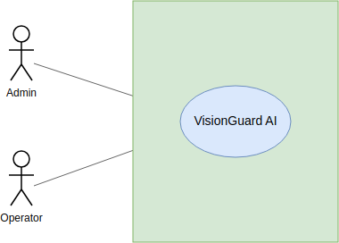

Fig 1: Use Case Level 0 (VisionGuard)

Level: 1
Use Case ID: 1
Name: VisionGuard AI: Detect, Enhance and Search
Primary Actor: Admin, Operator
Secondary Actor: None
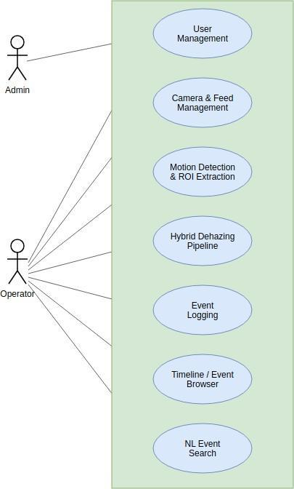

Fig 2: Use Case Level 1 (VisionGuard)

CRC Diagram
This chapter adds the Class-Responsibility-Collaborator (CRC) model of the final system. Each box in Fig 3 is one class and each arrow is labelled with the operation the source class calls on the target class, so the figure shows both the responsibilities (the operations) and the collaborators (the arrows). The operations are taken from the implemented code and the boxes are grouped by colour into entity classes, service classes, runtime and image-processing classes, and the access layer.

CRC Diagram of All Classes
The entity classes are the five database tables. The service classes hold all business logic and never touch HTTP or SQL directly. The runtime classes run the surveillance loop for every camera in background threads. The access classes are the thin layers at the two edges of the backend: routers and controllers towards the web, repositories towards PostgreSQL.
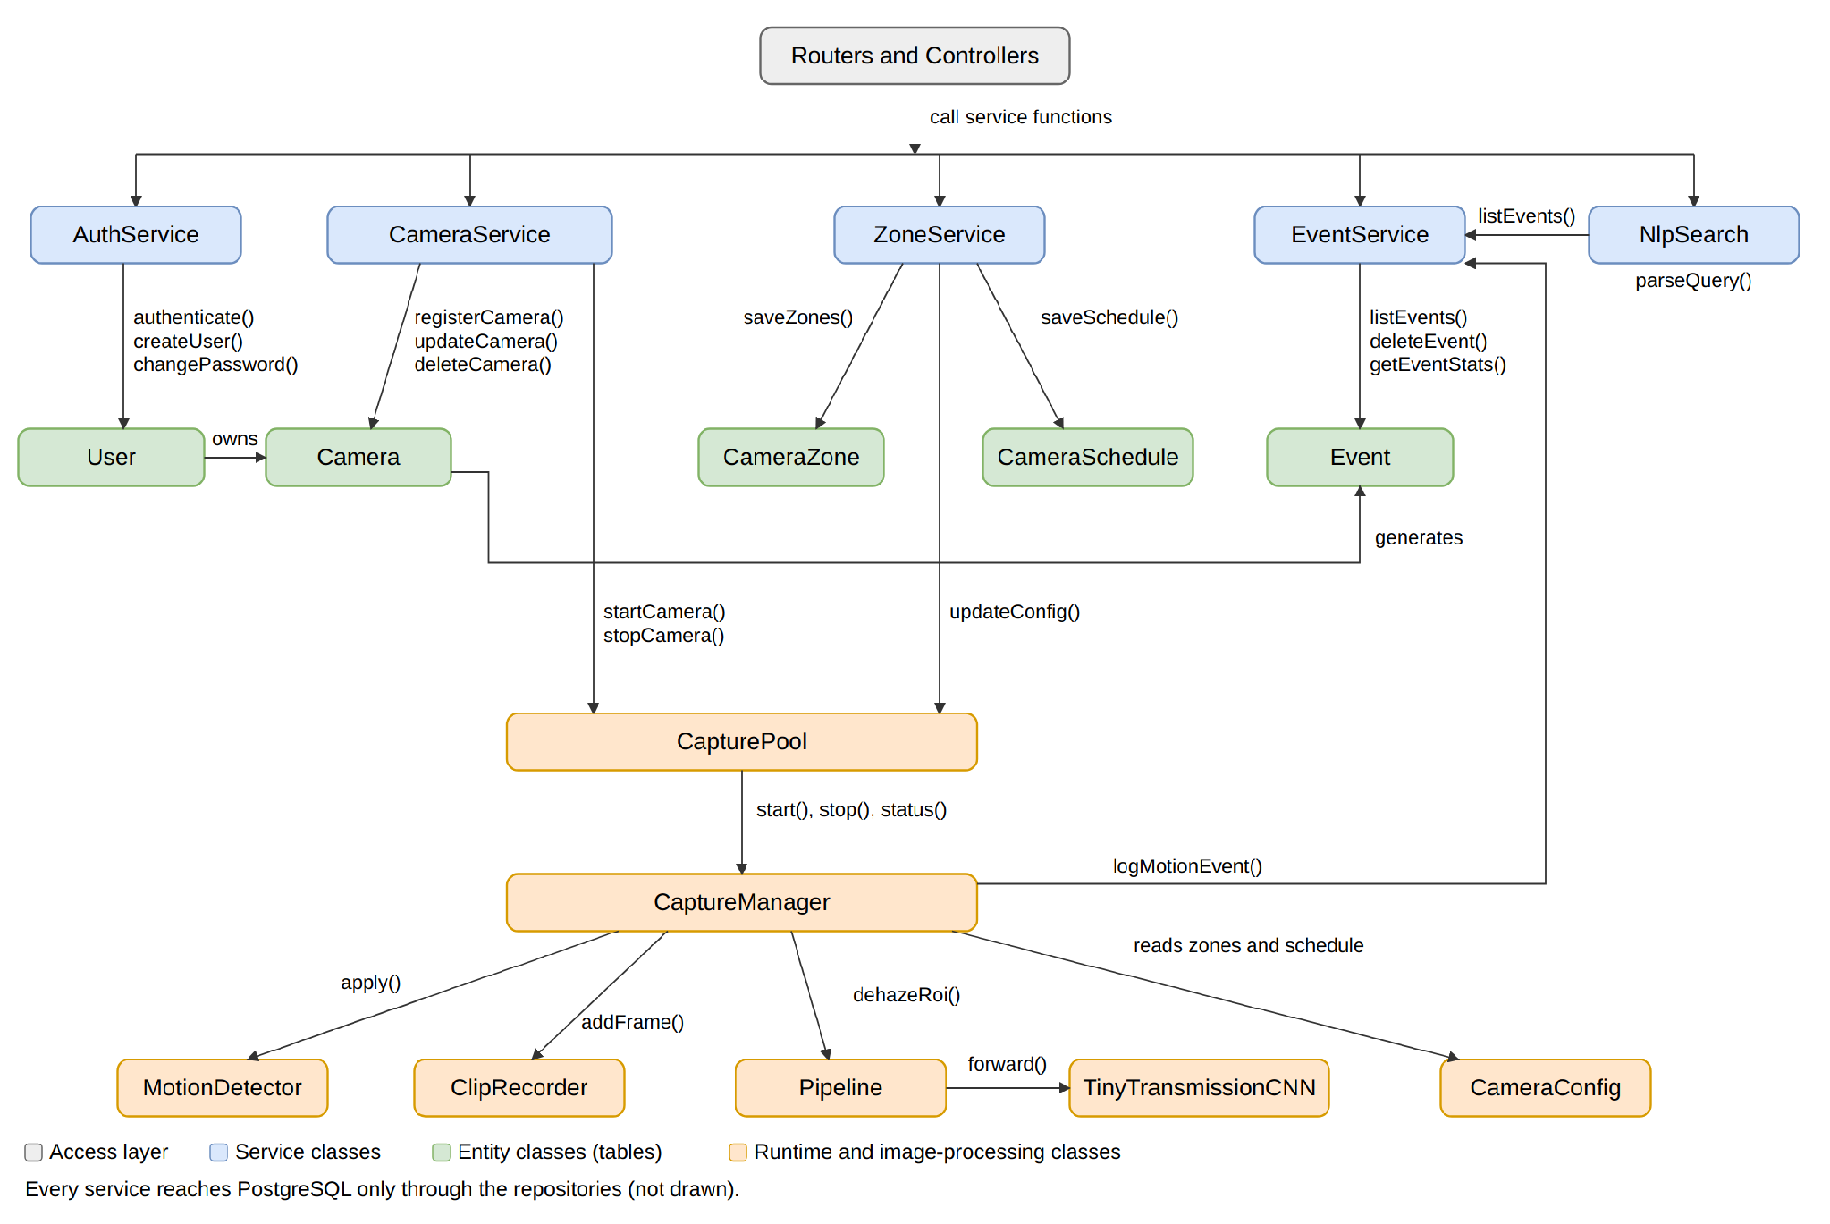
Fig 3: CRC diagram of VisionGuard (all classes)

Reading the Diagram
- Dependencies run in one direction only: Routers and Controllers call a service, a service calls a repository, and a repository talks to PostgreSQL. A repository never calls a service.
- CapturePool owns one CaptureManager per camera. Each CaptureManager works with its own MotionDetector, ClipRecorder and CameraConfig, so starting or stopping one camera never affects another.
- CameraConfig is replaced as a whole when zones or the schedule are saved. The capture thread reads it once per frame, so a change applies on the next frame without a lock.
- Ownership is enforced at the access layer: every repository query is filtered by the owner of the camera, so one user can never reach another user's cameras, events, snapshots or clips.
- AuthService, CameraService, ZoneService, EventService and NlpSearch are implemented as service modules of plain functions. They are drawn as classes here because each has a single responsibility and a clear set of collaborators.

ER Diagram and Dataset Description
The project grew after the technical report: cameras became a saved registry owned by one user, and detection zones and arming schedules were added. This chapter therefore adds an updated ER diagram. It shows tables and the relationships between them only. It extends the diagram of Chapter 4 and replaces it for the final system.

ER Diagram
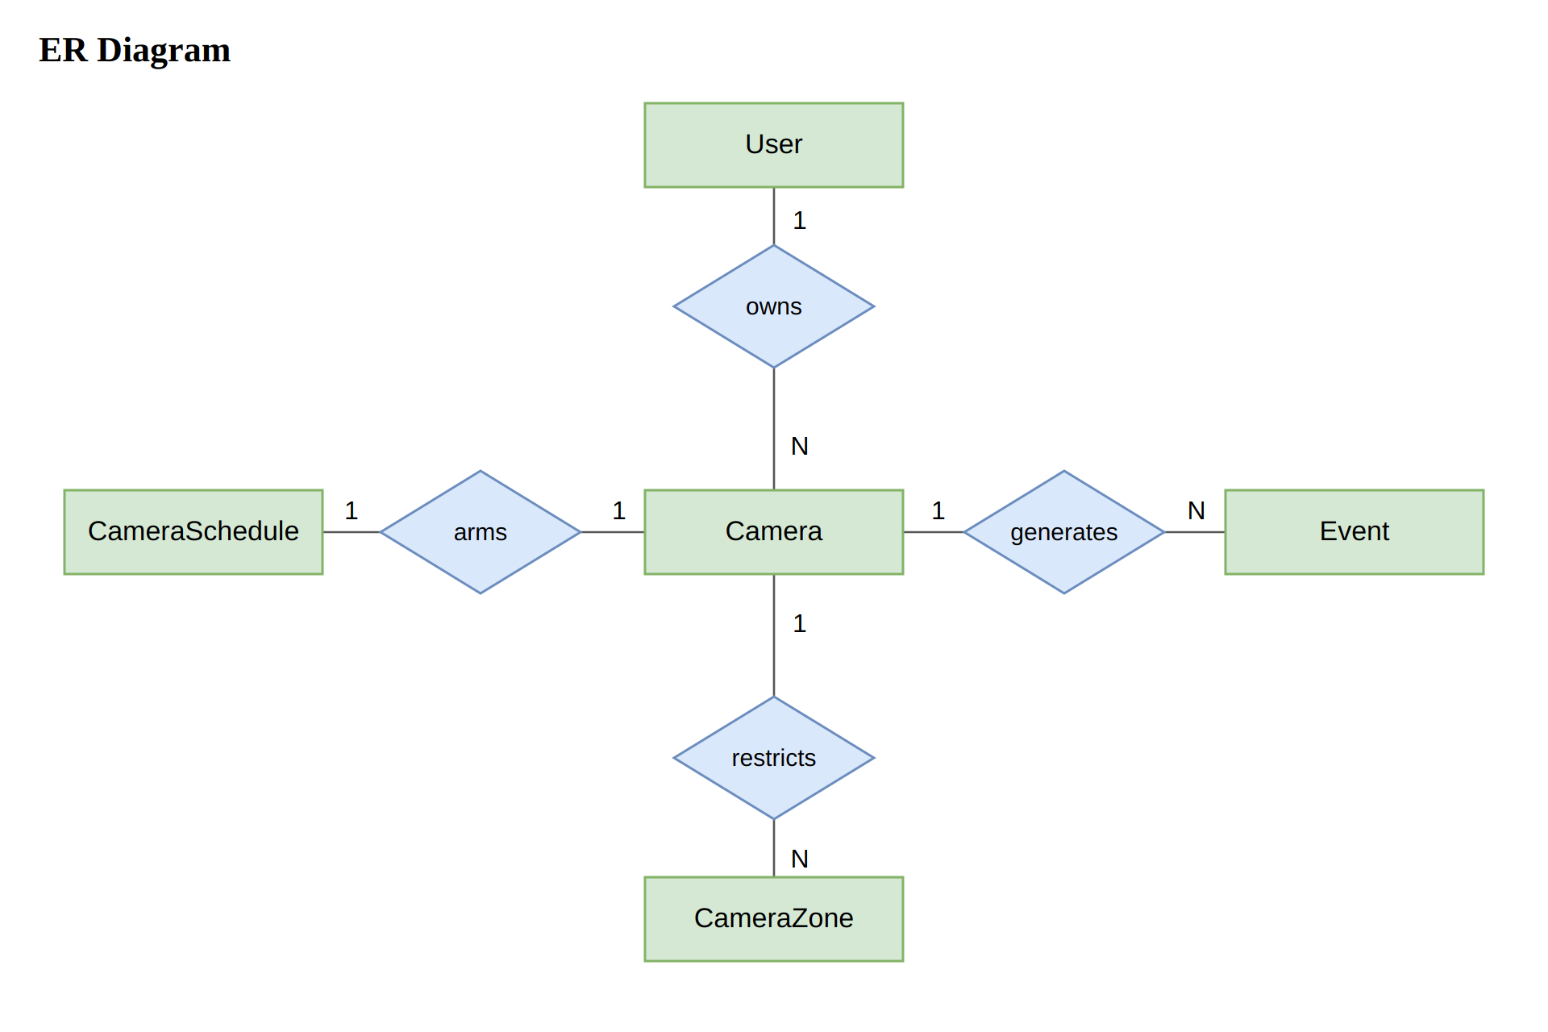
Fig 4: ER diagram of VisionGuard
Table 1: Relationships of the updated ER diagram
Relationship | Tables | Cardinality | Meaning
owns | User and Camera | 1 : N | A user owns many cameras. A camera belongs to exactly one user, and only that user can see it.
generates | Camera and Event | 1 : N | A camera generates many motion events. A removed camera is only marked as deleted, so its events are kept.
restricts | Camera and CameraZone | 1 : N | A camera can have several include or exclude detection zones.
arms | Camera and CameraSchedule | 1 : 1 | A camera has at most one weekly arming schedule.

- The Video Source table of the technical report is now the Camera table. A camera is saved once and started and stopped many times, instead of creating a new row on every start.
- The same stream address can be saved by two different users, because the address is unique only within one owner.
- Snapshot and clip files are stored on disk and the Event table keeps only their paths. Deleting an event also deletes its two files.

Dataset Description
The only data used to train a model is the data of the Tiny CNN that refines the transmission map. The CNN only has to correct the errors of the Dark Channel Prior, so it is trained and checked on real paired haze data instead of a generated one. REVIDE provides the training and validation pairs. The outdoor datasets RESIDE-HSTS and BeDDE are real-world outdoor haze benchmarks that cover the scenes of a campus, a parking lot or a street, which the indoor REVIDE scenes do not. The surveillance events are produced by the running system and are not used for training.
Table 2: Datasets used by VisionGuard
Dataset | Source | Size | Use
REVIDE | Public real-world paired haze dataset (CVPR 2021): the same indoor scenes with and without machine-generated haze | 1,697 hazy images | Training on real haze
RESIDE-HSTS | Hybrid Subjective Testing Set of the public RESIDE benchmark (IEEE TIP, 2019): outdoor scenes, real-world and synthetic haze | 20 hazy images (10 real-world, 10 synthetic) | Outdoor validation and testing, never trained on
BeDDE | Benchmark Dataset for Dehazing Evaluation (IEEE TIP, 2020): real outdoor hazy photographs with matching clear images of the same places | 208 hazy and clear image pairs from 23 cities | Outdoor validation and testing on real haze, never trained on
Event log | Produced by the running system: snapshot, clip, ROI box and size ratio of every motion event | Grows with use | Review, search and analytics only

- Input of each sample: three channels, the grayscale hazy ROI, its dark channel and the coarse DCP transmission map, all computed with the project's own DCP code so the CNN learns the real errors of that estimator.
- Label: there is no class label. The target is a refined transmission map. The datasets have no true transmission map, so the coarse DCP map is used as an anchor and the clean image of each pair is the reference.
- Loss: the main loss is the L1 distance between the image recovered with the predicted transmission and the clean image. A small term keeps the predicted transmission close to the coarse DCP map.
- Preprocessing: random 96 x 96 patches, a 15-pixel DCP window, values scaled to [0, 1] as float32, batches of 16.
- Training: Adam with learning rate 1e-3 halved every 8 epochs, 15 epochs by default. The weights with the best validation loss are saved to backend/weights/tiny_cnn.pth and loaded once at startup.

Behavioral Diagrams
This chapter explains the event flow of VisionGuard: how a frame becomes a stored event, and how an operator later reviews it. Fig 21 shows the states a camera and its events pass through, Fig 22 shows the whole system from sign-in to deletion in one sequence, and Fig 23 and Fig 24 then zoom into the two most detailed parts, the messages exchanged between the classes of Chapter 7.

State Transition Diagram of Event Flow
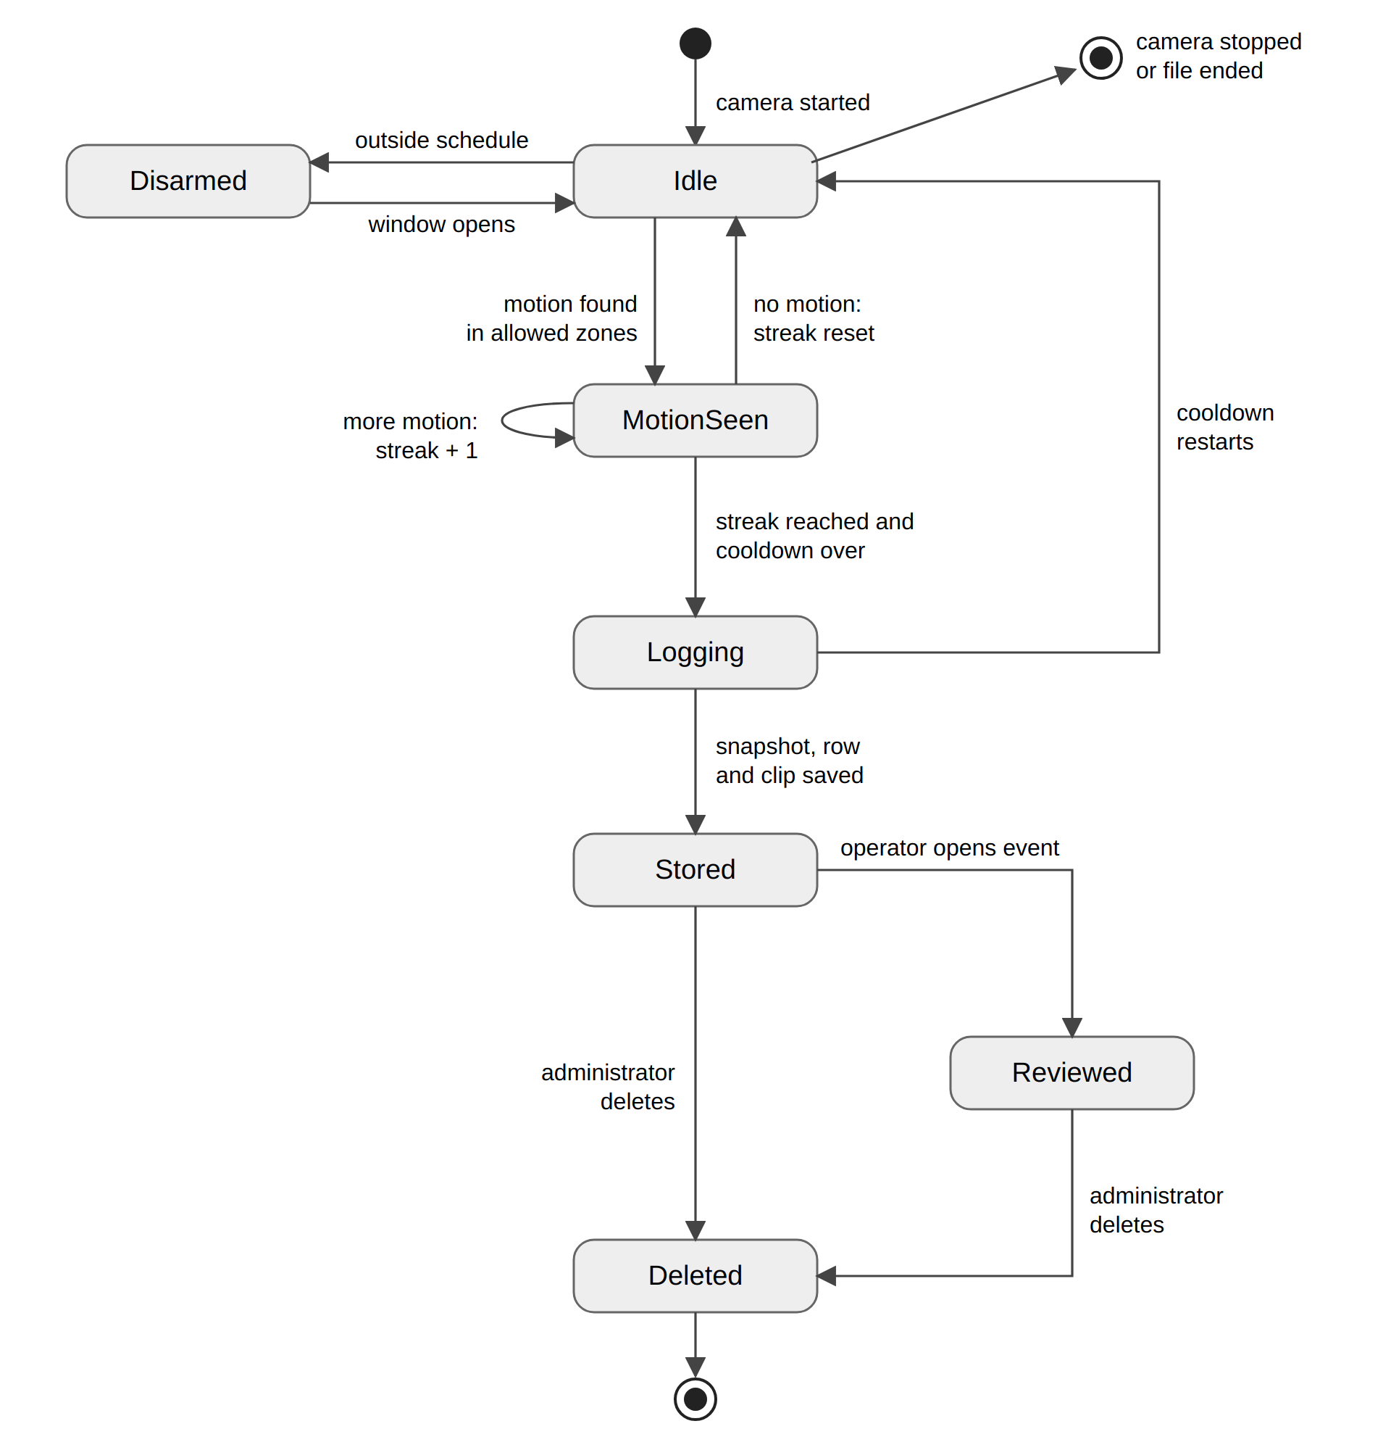
Fig 5: State transition diagram of the event flow
Table 3: States and transitions of the event flow
State | Meaning | Leaves the state when
Idle | The camera is running and armed. Every frame is checked for motion. | A motion region is found (MotionSeen), the schedule closes (Disarmed), or the camera is stopped or the file ends
Disarmed | The camera still streams, but detection is switched off by the weekly schedule | The schedule window opens again (Idle)
MotionSeen | A motion region inside the allowed zones was found. The motion streak counts consecutive frames with motion and the region is dehazed. | No motion in a frame resets the streak (Idle). When the streak reaches MOTION_MIN_FRAMES and the cooldown is over the event is logged
Logging | A background thread saves the snapshot and inserts the event row. The clip recorder reserves the clip file. | Snapshot, row and clip are saved (Stored). The camera goes back to Idle and the cooldown starts
Stored | The event can be listed, searched, viewed and counted in analytics | An operator opens it (Reviewed) or an administrator deletes it (Deleted)
Reviewed | An operator has opened the evidence inspector for the event | An administrator deletes it (Deleted)
Deleted | The row, the snapshot and the clip are removed | Final state

State Transition Diagram of Dehazing
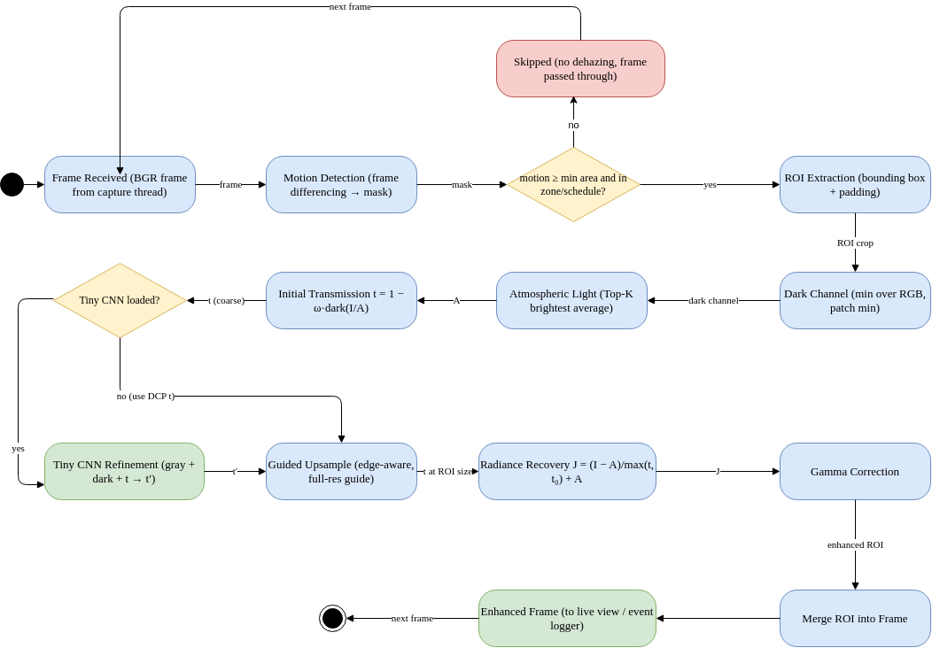
Fig 6: Dehazing pipeline sequence diagram of VisionGuard

End-to-End Sequence Diagram
Fig 22 follows one working session through every function of VisionGuard. The operator signs in, registers and starts a camera, sets zones and a schedule, and the capture thread then processes frames on its own. Later the operator reviews events, searches them in plain English, deletes an event (administrator only) and stops the camera. Every request carries the JWT and is limited to the cameras of the signed-in user.
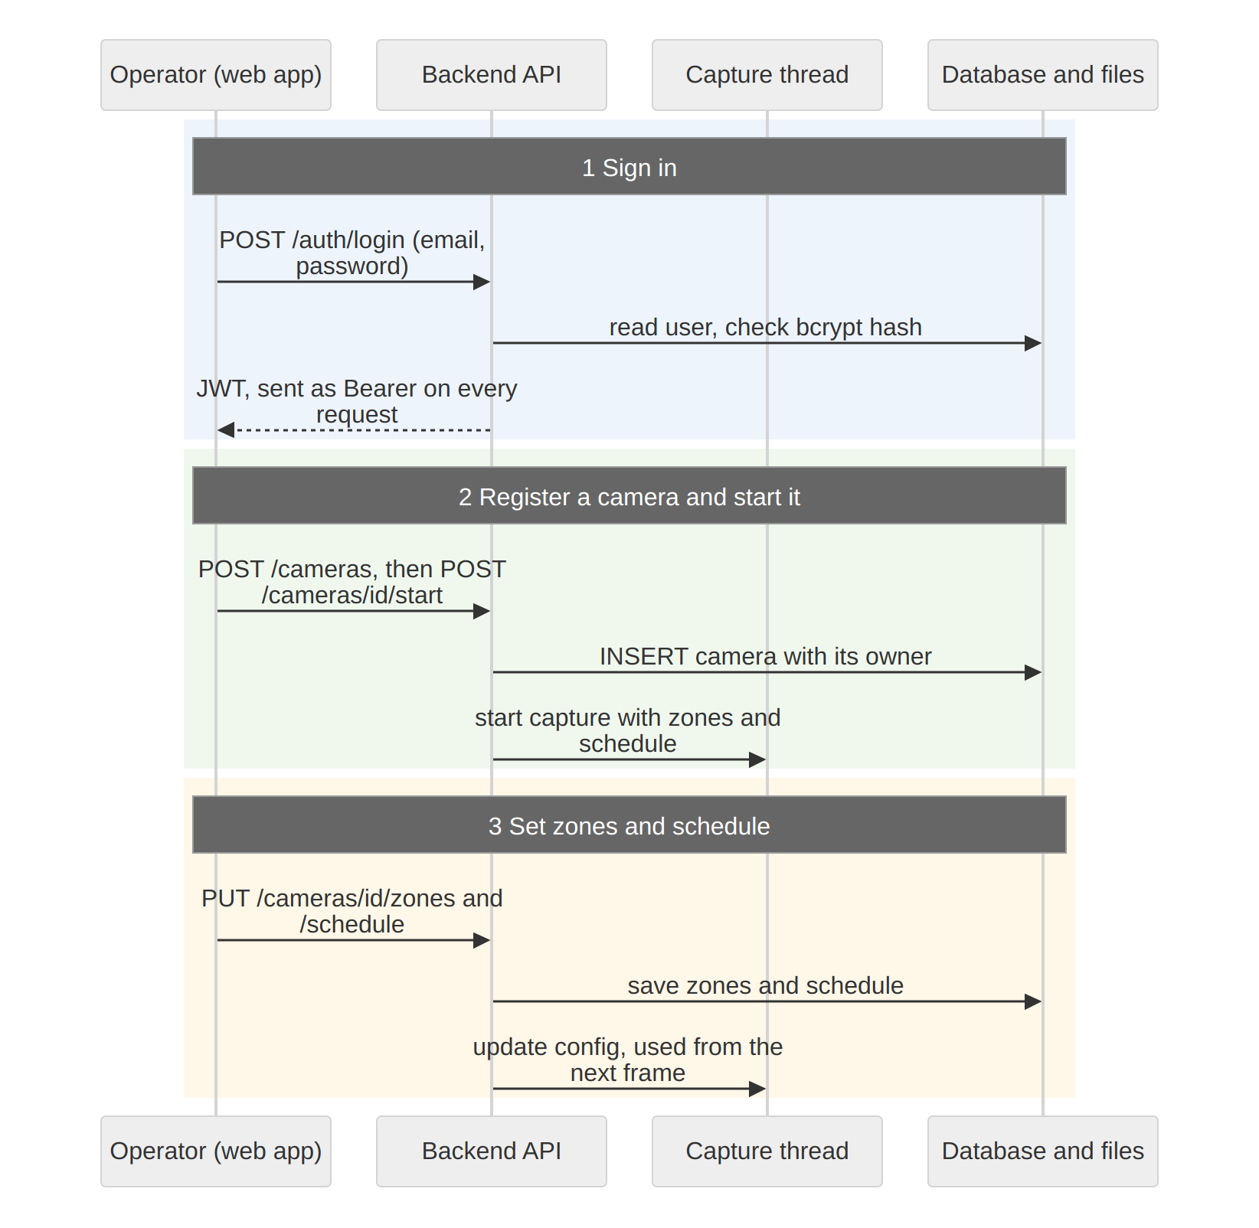
Fig 7: End-to-end sequence diagram of VisionGuard(1)
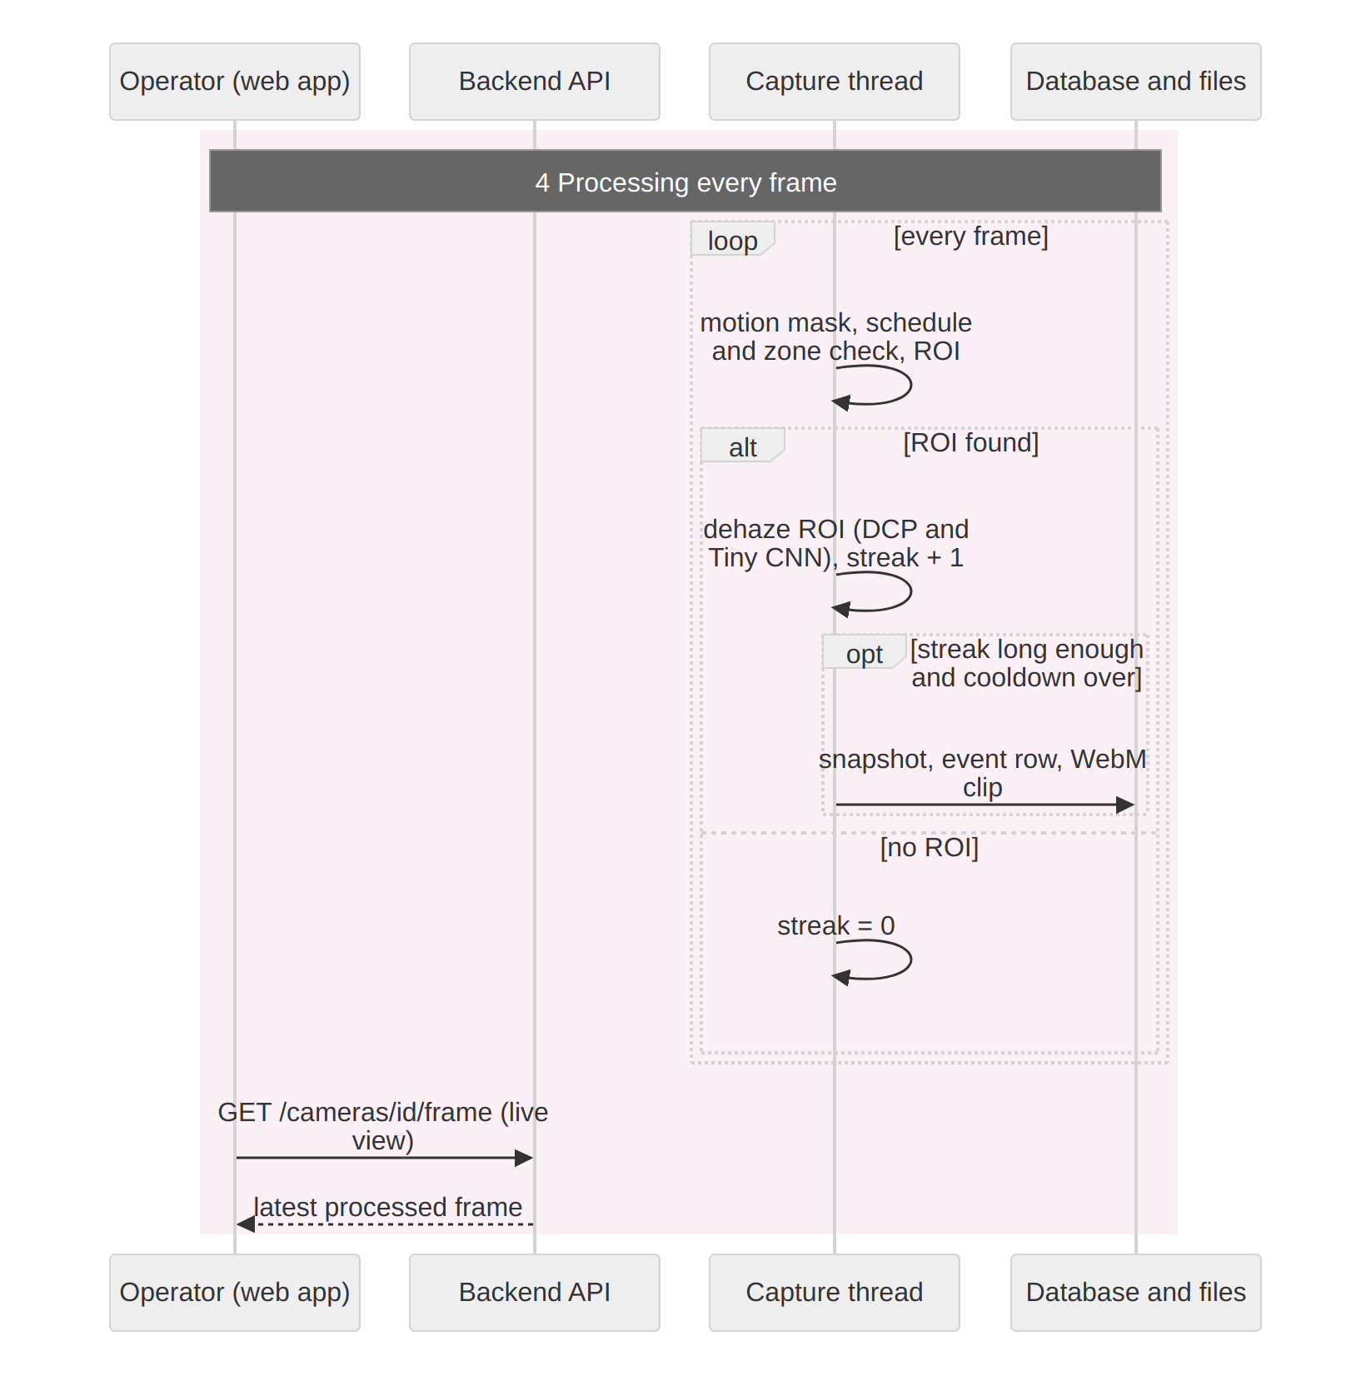
Fig 8: End-to-end sequence diagram of VisionGuard(2)
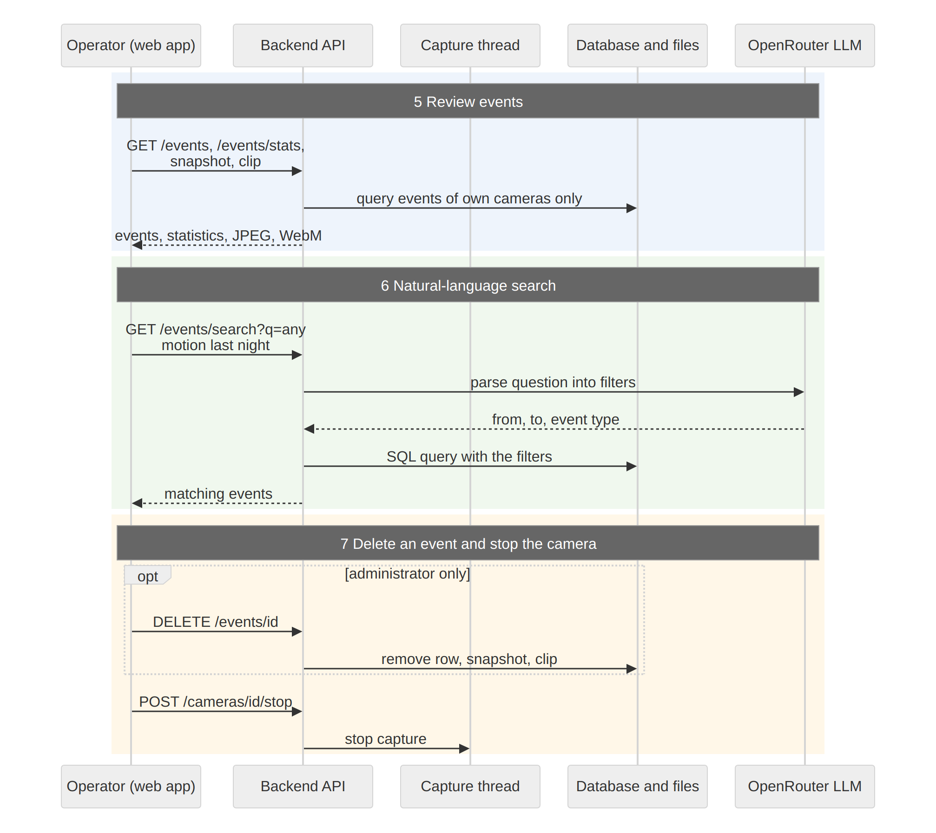
Fig 9: End-to-end sequence diagram of VisionGuard(3)
- Sign in: the backend checks the bcrypt hash and returns a JWT that the web app sends with every later request.
- Register and start: the camera row is stored with its owner and the capture thread is started for that camera.
- Zones and schedule: they are saved and pushed to the running capture thread, which uses them from the next frame.
- Processing: every frame goes through motion detection, the schedule and zone check and ROI extraction. Only the ROI is dehazed. A long enough motion streak outside the cooldown stores the snapshot, the event row and the clip. The live view reads the latest processed frame.
- Review: events, statistics, snapshots and clips are read from the database for the operator's own cameras only.
- Search: the question goes to the LLM, which returns time and type filters, and the filters drive an ordinary SQL query. If the LLM fails, all events are returned.
- Delete and stop: an administrator can delete an event with its files, and stopping a camera ends its capture thread.

Sequence Diagram: From Frame to Stored Event
Fig 23 follows one camera frame. The capture thread does the image work itself, but the slow work of writing files and inserting into the database is handed to a separate executor thread, so the next frame is never delayed by the disk or the database.
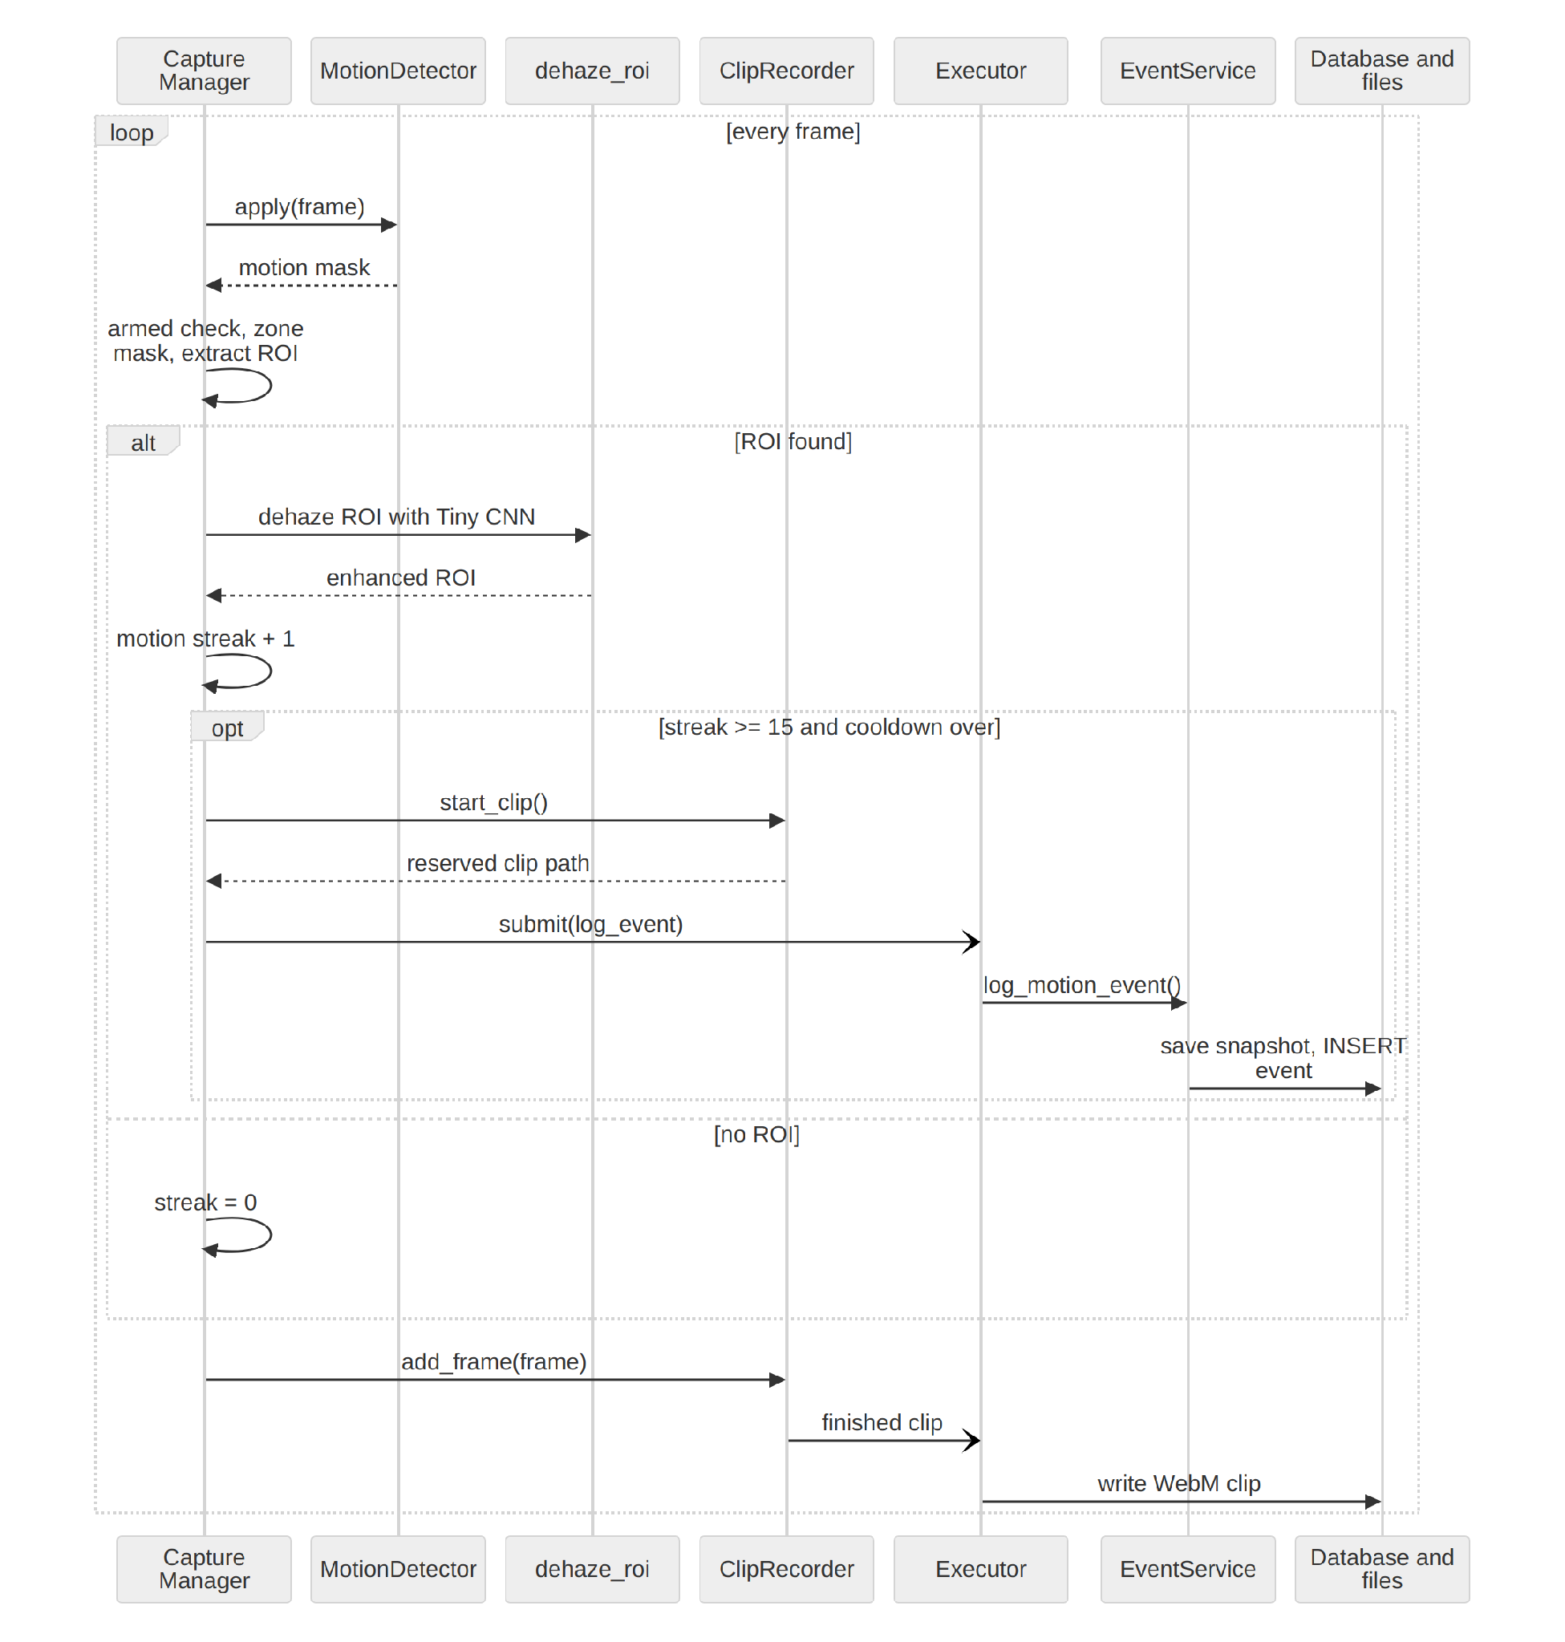
Fig 10: Sequence diagram: from frame to stored event
- For every frame the Capture Manager sends it to the MotionDetector and receives a motion mask.
- It checks the arming schedule, applies the zone mask and extracts the ROI. Without an ROI the motion streak is reset.
- With an ROI, only that region is dehazed (dark channel, Top-K atmospheric light, transmission, Tiny CNN refinement, radiance recovery and gamma) and merged back into the frame.
- When the streak is long enough and the cooldown is over, the Capture Manager asks the ClipRecorder to reserve a clip path and submits the logging job to the executor.
- The executor calls EventService, which writes the snapshot JPEG and inserts the event row.
- The ClipRecorder receives every frame. When the post-event recording is complete, the executor writes the WebM clip.

Sequence Diagram: Reviewing and Deleting an Event
Fig 24 shows how an operator reaches the stored evidence. Every request carries the JWT, and every query is limited to the cameras of the signed-in user. The clip file appears a few seconds after the event, so the first request can return 404 and the page retries. Only an administrator can delete an event.
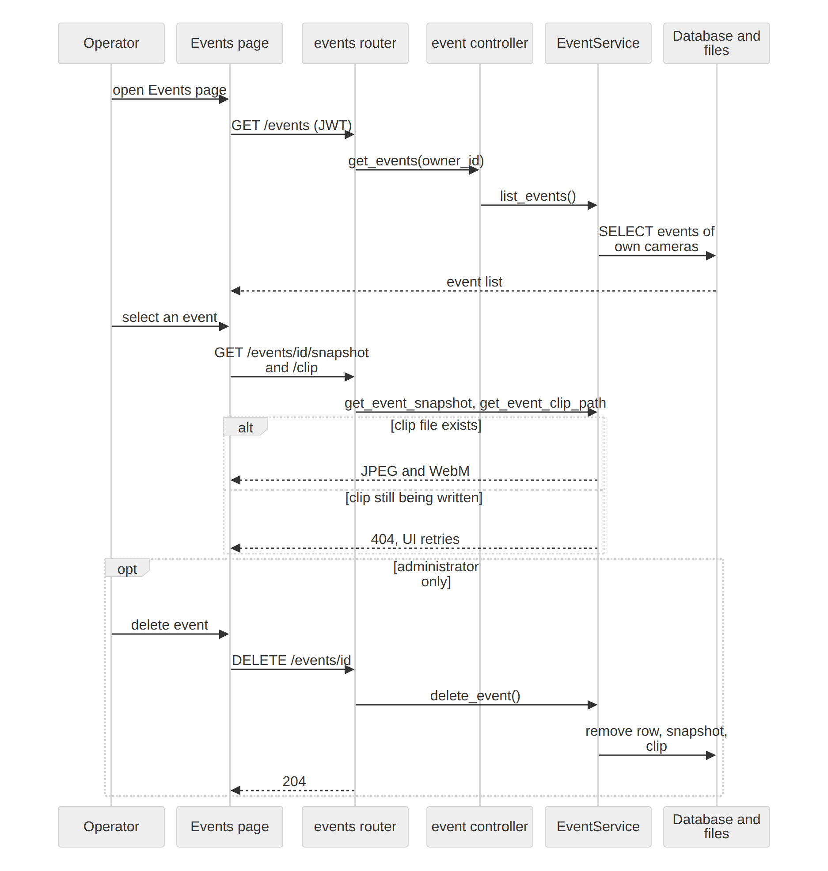
Fig 11: Sequence diagram: reviewing and deleting an event

User Manual
This manual explains how to start VisionGuard and how to use each page. All screenshots were taken from the running application with two demonstration sources: a hazy street video and a synthetic test video. The analytics numbers come from this test run and are not representative of a real deployment.

Starting the System
Requirements: Python 3.11 or later, Node.js 18 or later, PostgreSQL 14 or later (a docker-compose file for the database is included) and a current browser. No GPU is needed. An OpenRouter API key is optional and only enables natural-language search.
- Copy .env.example to .env and set the POSTGRES values, a long random JWT_SECRET_KEY, and ADMIN_EMAIL and ADMIN_PASSWORD. These two create the first administrator when the system starts.
- Start the database (docker compose up -d db, or createdb visionguard on an existing PostgreSQL).
- From the repository root run: python3 -m venv venv, source venv/bin/activate, pip install -r requirements.txt, then uvicorn backend.main:app. Database tables are created and updated automatically at startup.
- In a second terminal run: cd frontend, npm install, cp .env.example .env, npm run dev.
- Open http://localhost:5173 in the browser.

Signing In
The landing page introduces the system. Choose Sign in, then enter your email and password (Fig 25). There is no sign-up page: the administrator creates operator accounts. A wrong password shows an error and keeps you on the sign-in page. You are signed out automatically when the session expires or the account is deactivated.
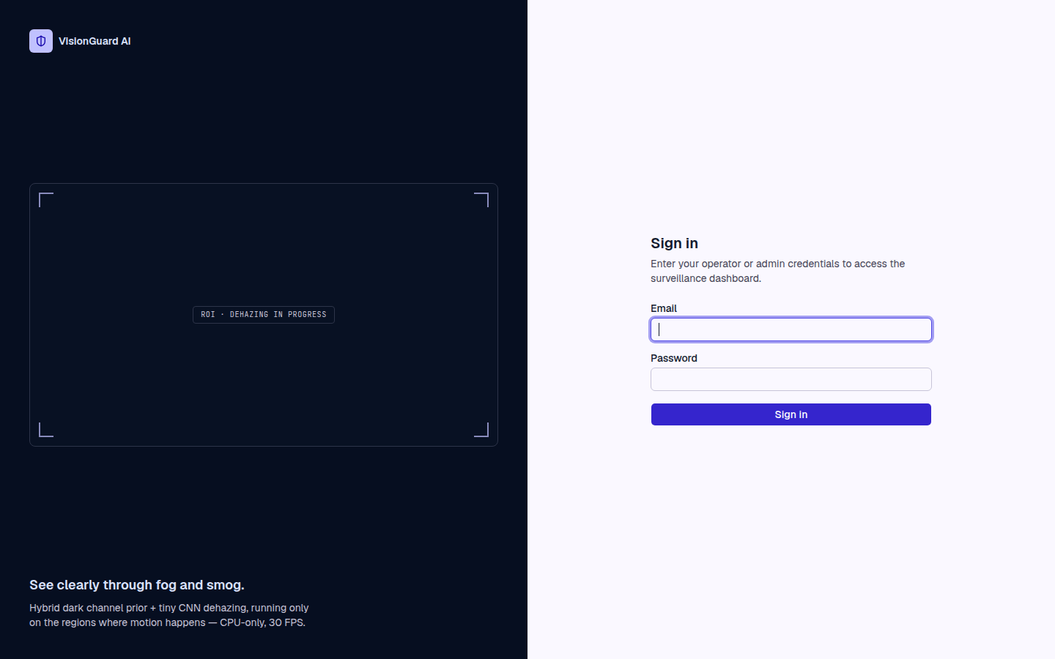
Fig 12: Sign-in page

Live Monitoring
Live Monitoring (Fig 26) shows one tile for every running camera. A green box marks where motion was found and the picture inside the box is the dehazed region. Each tile has a LIVE badge, the number of zones, Configure and Stop buttons. The chips above the tiles and the search box filter the cameras, Grid and Focus change the layout, and the Recent events strip at the bottom links to the newest events.
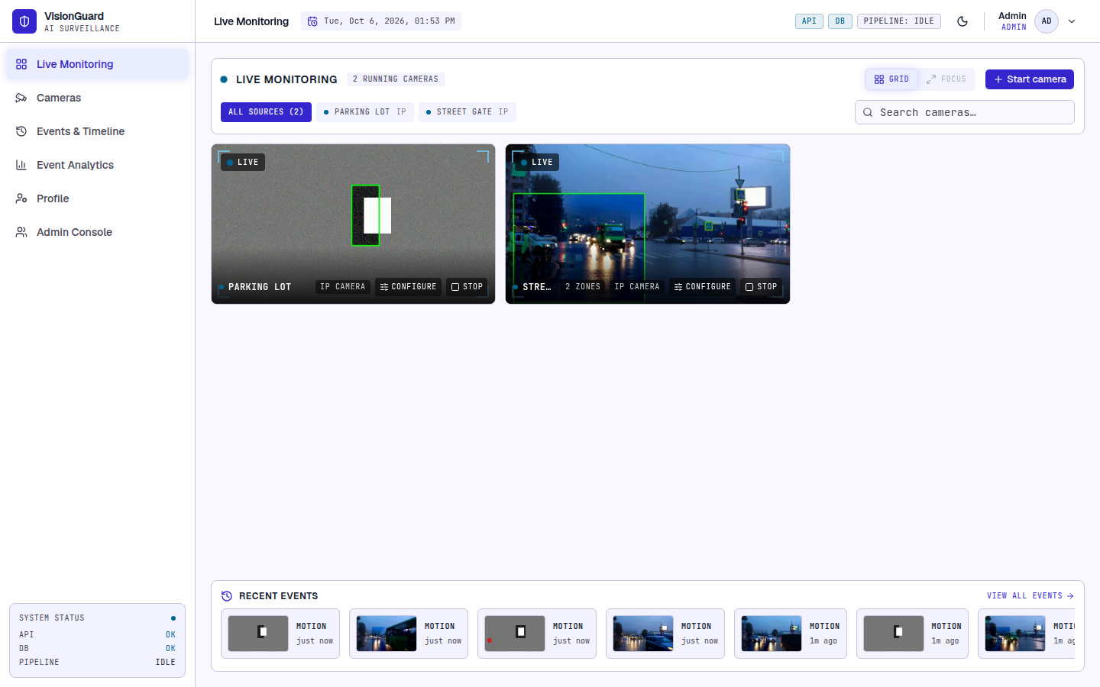
Fig 13: Live Monitoring with two running cameras
Press Start camera (Fig 27) to start a saved camera, to save and start a new webcam index, stream address (for example rtsp://...) or file path with Save & start, or to process a video file with Upload video. A camera made from an uploaded file stops by itself when the video ends.
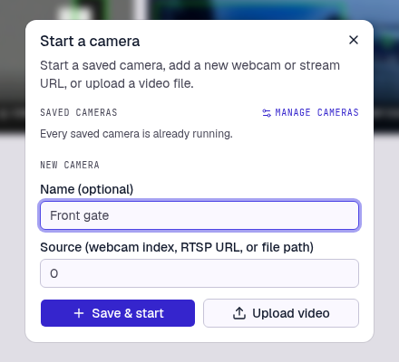
Fig 14: Start a camera dialog

Managing Cameras
The Cameras page (Fig 28) is the registry of saved cameras. Add a camera on the left with an optional name and its source, and press Save camera. The list on the right shows the type and status of each camera (running, stopped, ended, offline or error) and has buttons to start or stop it, configure zones and schedule, edit the name or source (the source can only be changed while the camera is stopped) and delete it. Deleting a camera stops it, but its events are kept.
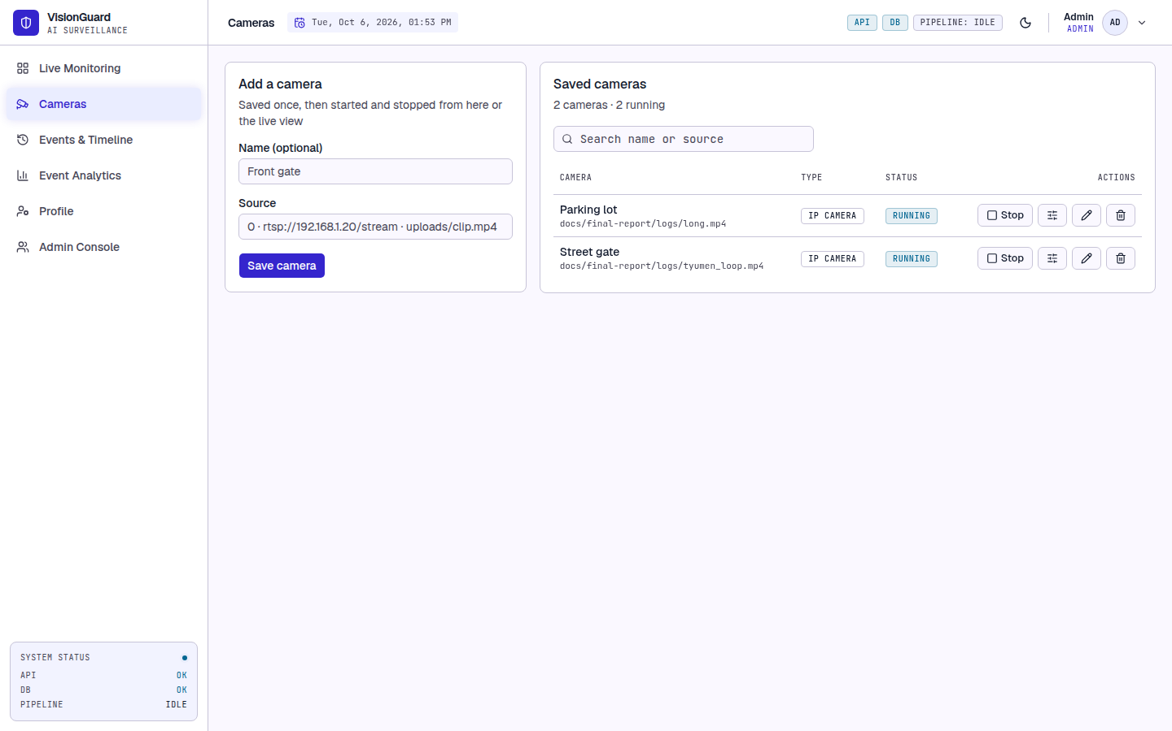
Fig 15: Cameras page

Detection Zones and Schedule
- On the Cameras page press the configure button of a camera. The Zones tab (Fig 29) shows the live picture.
- Choose Exclude (ignore this area, for example sky, trees or a busy road) or Include (watch only this area), click at least three corners on the picture and press Finish zone. Repeat for more zones. Zones can be renamed or deleted in the list below the picture.
- Press Save zones. The running camera uses the new zones from the next frame, with no restart. If there is any include zone only those areas are watched, minus any exclude zone inside them. With only exclude zones the whole picture is watched except those areas.
- Open the Schedule tab (Fig 30), tick Use a schedule, choose the weekdays and set Armed from and Until. An end time earlier than the start time continues past midnight. Press Save schedule. Outside the window the camera keeps streaming but is disarmed and logs no events.
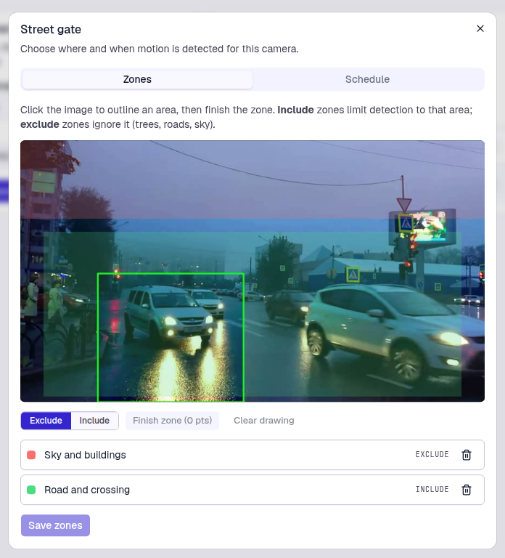
Fig 16: Zones tab (red = exclude, green = include)
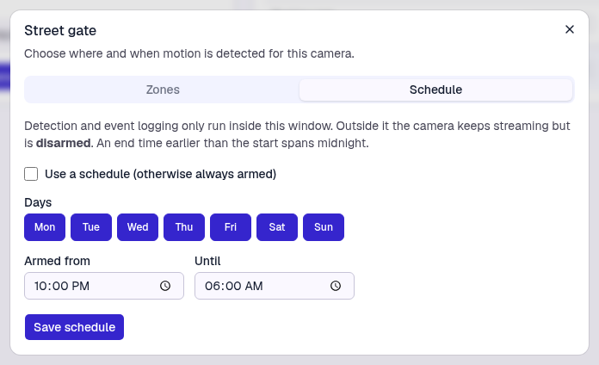
Fig 17: Schedule tab

Events and Timeline
Events & Timeline (Fig 31) lists the logged events of your cameras, grouped by day with the newest first. Each card shows a thumbnail, the ROI position and size, the camera and the frame number, and a Clip badge when a video exists. Click an event to open the Evidence inspector on the right. Video clip plays the few seconds before and after the event with the motion box, and Snapshot (Fig 32) shows the still image. Open full size opens the image in a new tab. While a clip is still being recorded the inspector shows a short waiting message and loads the clip when it is ready.
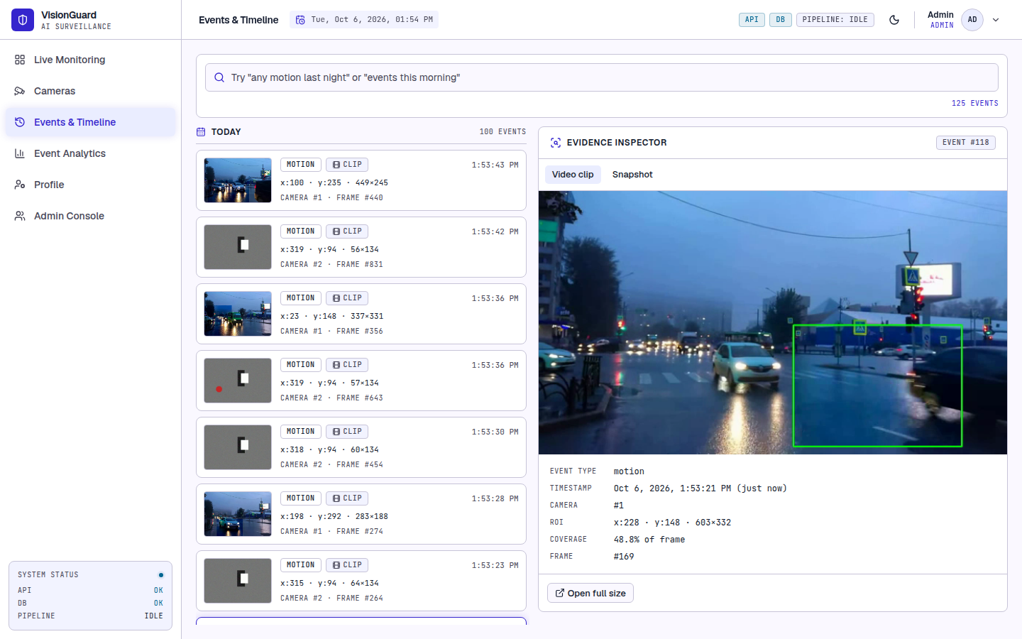
Fig 18: Events & Timeline with the video clip of an event
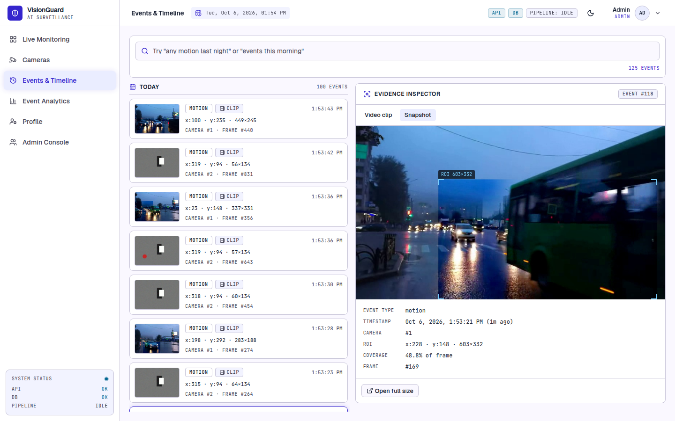
Fig 19: Evidence inspector, snapshot view
To search, type a plain-English question such as "any motion last night?" in the search box and press Enter. The question is turned into a time range by a language model and the matching events are shown with filter chips. If the key is missing or the question cannot be understood, all events are shown instead of an error. Events are recorded as motion. VisionGuard does not decide whether the motion is a person or a vehicle, so watch the clip to decide.

Event Analytics
Event Analytics (Fig 33) summarises the events of the chosen time range and camera: total events, busiest hour and most active camera, events per day, events by hour of day and a weekday by hour heatmap. Use it to choose where to add exclude zones and when to arm a camera.
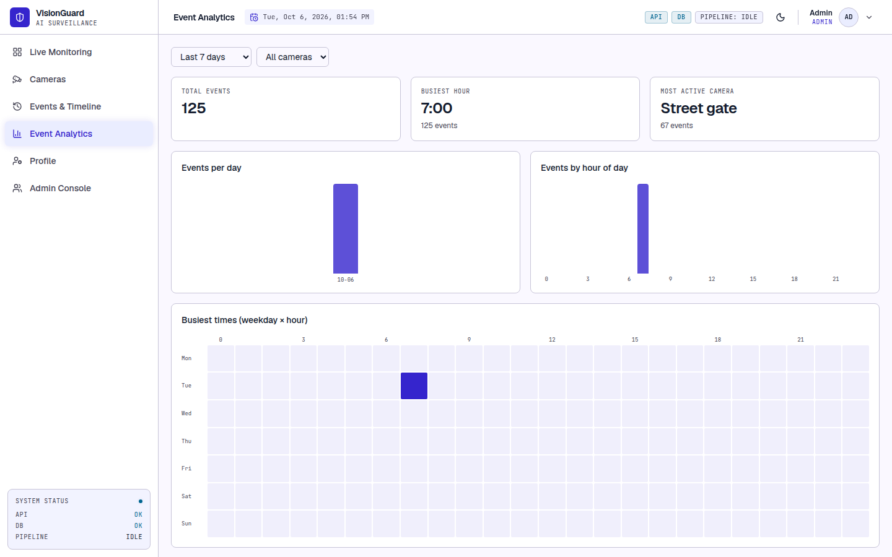
Fig 20: Event Analytics

Profile and Administration
On the Profile page (Fig 34) the Details tab changes your name and email (the email is your sign-in name) and the Security tab changes your password, which must be at least 8 characters.
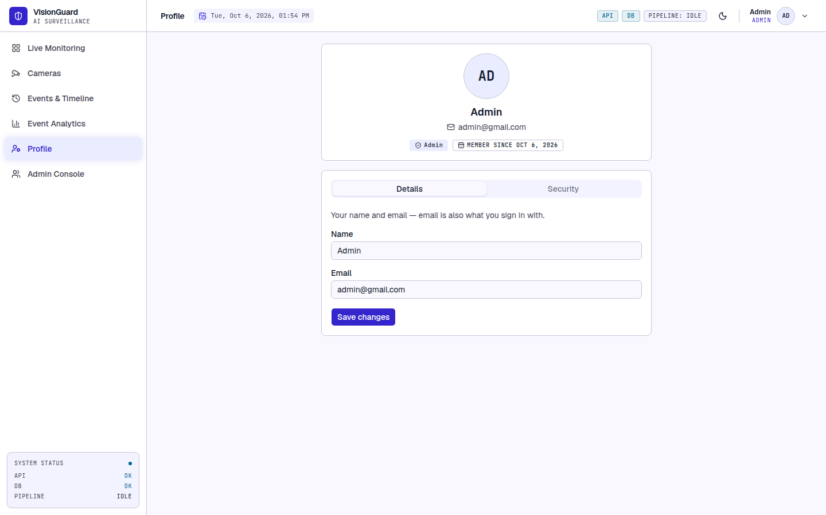
Fig 21: Profile page
Only administrators see the Admin Console. The Accounts tab (Fig 35) creates operator accounts and activates or deactivates accounts. A deactivated person can no longer sign in, but the account is not deleted. You cannot deactivate yourself or the last active administrator. The Events tab (Fig 36) lists events with a Delete button, which removes the event together with its snapshot and clip.
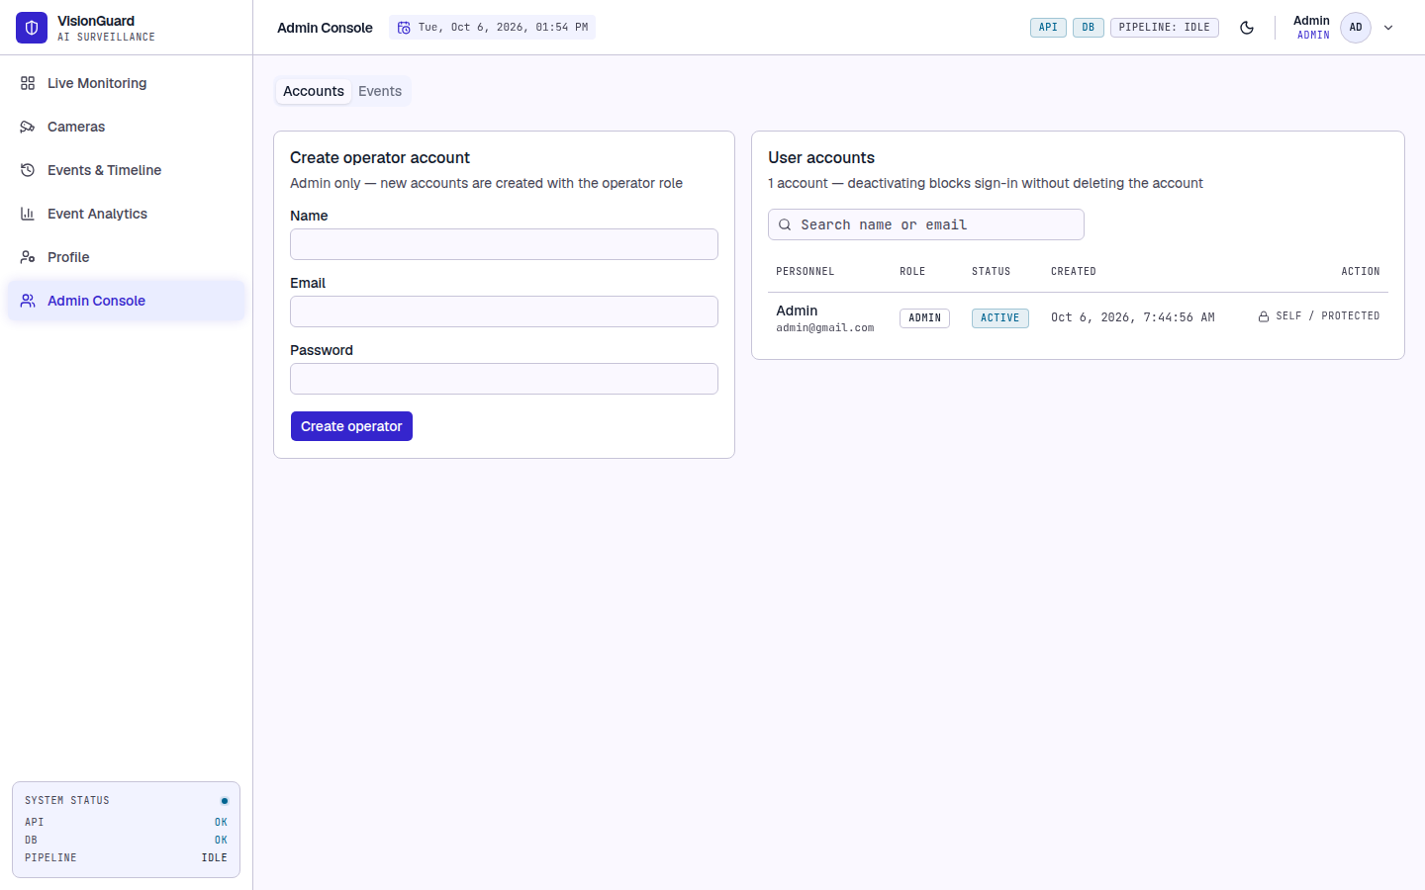
Fig 22: Admin Console, Accounts tab
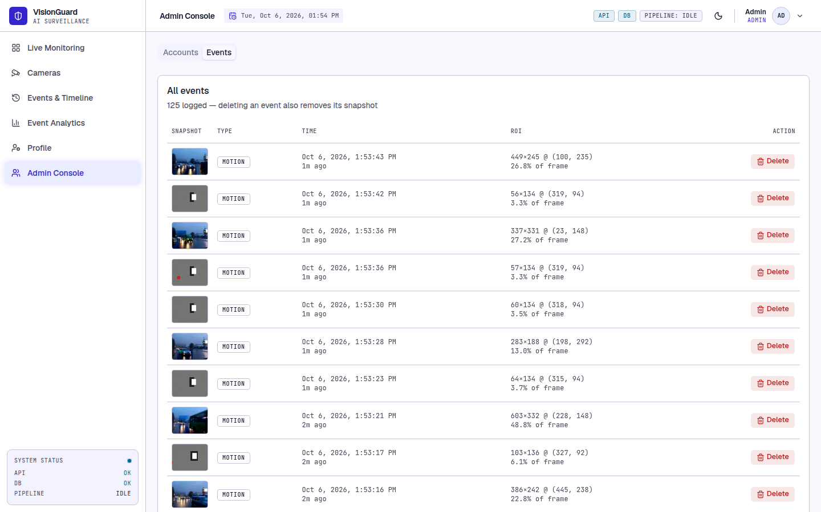
Fig 23: Admin Console, Events tab
Every user works in a private space: a camera and everything under it (events, snapshots, clips, zones, schedule and statistics) is visible only to the user who saved it, administrators included.

Troubleshooting
Table 8: Common problems
Problem | Likely cause and what to do
"Cannot open video source" | Wrong address, camera offline, or the path does not exist on the server. Check the address in a media player.
No events appear | The camera is disarmed, the motion is outside the include zones, or the motion is shorter than the minimum duration. Check the schedule and zones.
Too many events | Foliage, shadows or lighting changes. Add exclude zones or raise MOTION_MIN_FRAMES or MOTION_MIN_AREA in .env.
Clip is not available | The clip is written a few seconds after the event. Wait and select the event again. The snapshot is always available.
Search returns every event | No time range was understood or no OpenRouter key is set. Rephrase with a time such as "yesterday" or set OPENROUTER_API_KEY.
Signed out unexpectedly | The session expired or the account was deactivated. Sign in again or ask an administrator.

Testing
This chapter is the test plan and the test report of the final system. It describes how VisionGuard is tested, when an item passes or fails, which risks were identified with their contingencies, and the test cases with their detailed outcomes.

Testing Approach and Strategy
Testing combines automated tests at two levels with a manual walkthrough of the user interface. The unit level checks the image-processing and decision logic in isolation, the API level checks the running system through its HTTP interface, and the manual level checks the pages that an operator uses.
Table 9: Test levels
Level | Tooling | Scope | Run against
Unit | pytest | Dark channel, transmission and atmospheric light, CNN inference and loading, motion detector, ROI extraction, pipeline round trip, zone masks, schedule evaluation, natural-language query parsing | In-process, synthetic arrays and mocked HTTP
API acceptance | tests/acceptance_api.py (httpx, OpenCV) | Authentication and roles, camera start and stop, upload validation, motion and persistence behaviour on synthetic videos, zones, schedules, settings carry-over, snapshots, clips, filters, analytics, search fallback, health, deletion | Live uvicorn server and real PostgreSQL
System / manual | Browser walkthrough | End-to-end behaviour through the interface: sign-in, adding cameras, drawing zones, saving schedules, playing clips, analytics | Running frontend and backend with real hazy footage

Synthetic videos make the acceptance cases deterministic. A 20-second clip of a bright rectangle moving over a noisy grey background must produce motion events. A clip with nothing moving must produce none, and a clip with a 6-frame blink every 3 seconds must produce none because it is shorter than the minimum duration. Several copies of the moving clip run at the same time, each with different zone or schedule settings, so that the effect of each setting is isolated.

Test environment:
- Machine: Intel Core i5-1240P, 16 logical CPUs, 7 GB RAM, Linux, no GPU.
- Backend: Python virtual environment, uvicorn on port 8000, PostgreSQL on localhost. Frontend: Vite dev server on port 5173.
- Browser: Chrome, driven by Puppeteer, for the interface walkthrough.
- No OpenRouter key was configured in the acceptance run, so only the search fallback was exercised there. The query parsing itself is covered by the unit tests with mocked responses.

Item Pass and Fail Criteria
- A test case passes when the actual result equals the expected result in every stated part (status code, content type, count, state). Anything else is a fail.
- The unit suite must pass completely (50 of 50) before an acceptance run starts.
- The acceptance run passes when every case passes. A failing case must be fixed, or recorded as a known defect with a contingency, before the release is accepted.
- Suspension criterion: if the server cannot start or the database is unreachable, the run is suspended and resumes after the environment is repaired.
Table 10: Items under test with their pass and fail criteria
Item | Requirement | Passes when | Fails when
Authentication and roles | FR-9, FR-16 | A valid login returns a token, every other route rejects a missing token, an operator cannot manage accounts or delete events | A protected route answers without a token or an operator action is allowed
Start, upload and stop cameras | FR-1, FR-2, FR-10 | A reachable source starts, an unreachable or non-video source returns 400, stopping an inactive camera returns 404 | An unclear error, a crash, or a source left active after a failed start
Motion detection and ROI | FR-3, FR-4 | A static scene gives no event, a moving object gives an ROI with a positive size inside the frame | An event from a static scene or a missing or oversized ROI
Hybrid dehazing | FR-5 | Output keeps shape and type, recovered scene is closer to the clean image than the hazy input, contrast increases | Wrong shape, no improvement, or an exception on a valid ROI
Event logging, persistence and cooldown | FR-6, FR-13 | Motion shorter than the minimum is ignored, events carry ROI and area ratio, the gap between events is at least the cooldown | A short blink creates an event or events are logged faster than the cooldown
Zones and schedules | FR-11, FR-12 | Excluded or outside-include motion logs nothing, invalid zones and schedules are rejected, a disarmed camera logs nothing | An event from an ignored area or an invalid zone is accepted
Timeline and filters | FR-7 | Pagination and time filters return the right events and totals | Wrong counts or events outside the filter
Natural-language search | FR-8 | Filters are parsed from the reply, and any failure returns all events without an error | A failure of the language model breaks the search
Event snapshots and clips | FR-14 | The snapshot is a JPEG and the clip a non-empty WebM, an unknown event gives 404 | A missing, empty or wrongly typed file
Analytics | FR-15 | Totals equal the sums per day, per camera and in the heatmap | Inconsistent totals
Data isolation and deletion | FR-17, FR-18 | An administrator delete returns 204 and removes the snapshot, other users' data stays hidden | A file remains after delete or another user's data is visible
System status | FR-19 | Status 200 with the database reported as ok | No answer or a wrong database state

Risks and Contingencies
Table 11: Risks and contingencies
Risk | Likelihood / impact | Contingency
The language model service is unavailable or the key is missing | Medium / low | Search falls back to unfiltered results and the timeline stays fully usable. No error is shown to the operator.
CNN weights are missing or corrupt | Low / medium | The loader returns nothing and the pipeline runs pure DCP. A warning is logged at startup.
Processing is slower than the camera frame rate | Medium / medium | The live reader drops stale frames so latency stays bounded. The ROI size cap, the downscaled stages and the thread caps limit the cost, and the thresholds are configurable.
Many false events from foliage, shadows or lighting changes | High / medium | Exclude zones remove those areas, schedules silence cameras, the minimum duration and the cooldown suppress flicker, and the area ratio helps filter small motion.
Disk fills with snapshots, clips and uploads | Medium / high | The directories are configurable and can move to larger storage. Deleting an event removes its files. Automatic retention is future work.
Clip memory use is too high on small hardware | Medium / medium | Lower the clip width, the clip frame rate or the seconds kept before an event.
A camera becomes unreachable | Medium / medium | The capture thread ends and the camera shows as offline or ended. The operator starts it again and its zones and schedule are still saved.
The server stops while cameras are running | Low / medium | Running state is held in memory only, so after a restart every camera shows as stopped and no ghost camera remains.
Server and operators are in different time zones | Medium / low | The schedule time zone is an explicit setting, and event times are shown in the browser's local time.
The database is unavailable | Low / high | The status endpoint reports the database state, the API returns errors and it recovers when the database returns.

Some areas were not tested and remain open risks:
- Query parsing with a live language model was only tested with mocked responses and the fallback path, because no real key was used in the final run.
- Physical webcams and RTSP cameras were not used in the final run. Uploaded files exercise the same processing path.
- Long-duration and many-camera load tests were not performed, so sustained 30 FPS with many cameras is not claimed.
- Cross-browser testing covered Chrome only, and there are no automated frontend tests. The interface is covered by the manual walkthrough and by strict TypeScript.

Test Cases with Detailed Outcomes
The unit suite ran with pytest over the tests folder: 50 tests in about two seconds, 50 passed and none failed. The behaviours checked in every file are listed in Table 12.
Table 12: Unit tests by file: behaviours verified and results
File | Tests | Behaviours verified | Result
test_dark_channel.py | 5 | An all-black image has a dark channel of zero; an all-white image has one; the dark channel never exceeds the per-pixel channel minimum; saturated colours give a low dark channel; one dark pixel darkens the whole patch window | All pass
test_transmission.py | 4 | Haze-free regions estimate a high transmission; fully hazy regions estimate a low one; transmission stays within 0 and 1; atmospheric light is the Top-K average, not a single brightest pixel | All pass
test_cnn_inference.py | 7 | Forward pass returns one channel in (0, 1); the refined map keeps the input size; oversized ROIs are refined at a capped size and restored; no model means pure DCP; the output is a valid uint8 image; a missing weights file returns None; saved weights reload to an identical model | All pass
test_motion_detector.py | 3 | A static scene yields no foreground; a moving object yields foreground pixels; the mask contains only 0 and 255 | All pass
test_roi.py | 7 | No motion gives no ROI; a single blob gives a padded box; small blobs are ignored; nearby blobs merge into one box; scattered motion falls back to the largest blob; merging respects the area cap; padding never leaves the frame | All pass
test_pipeline.py | 3 | The pipeline keeps shape and type; the recovered scene is closer to the ground truth than the hazy input; dehazing increases contrast | All pass
test_zones.py | 5 | No zones means no mask; an include zone limits detection to its area; an exclude zone removes its area; exclude cuts a hole in an include zone; motion outside an include zone is masked away | All pass
test_schedule.py | 6 | No or disabled schedule means always armed; a same-day window arms inside and disarms outside; unselected weekdays are disarmed; an overnight window covers the evening and the next morning; early morning belongs to the previous weekday's window | All pass
test_nlp_search.py | 10 | A missing key gives no filters; a structured reply is parsed into filters; unknown event types and bad timestamps are dropped; errors, bad replies and empty replies degrade to no filters; time zones are converted; a rate-limited request is retried and the retries are bounded | All pass

The script tests/acceptance_api.py ran 37 cases against the live server, 37 passed and 0 failed. Table 13 lists the expected and the observed outcome of every case.
Table 13: API acceptance test cases with expected and actual outcomes
ID | Case | Expected outcome | Actual outcome | Result
TC-01 | Admin login with valid credentials | 200 and a JWT access token | 200, token issued=True | Pass
TC-02 | Login with a wrong password | 401, no token | 401 | Pass
TC-03 | Protected route without a token | 401 before any controller logic | 401 | Pass
TC-04 | Admin creates an operator account | 200/201 with role operator | 201, role=operator | Pass
TC-05 | Two accounts may share a display name | 200/201 (email is the unique key, not the name) | 201 | Pass
TC-06 | Operator cannot create accounts | 403, no account created | 403 | Pass
TC-07 | Operator cannot delete events | 403 | 403 | Pass
TC-08 | Change password with a wrong current password | Rejected (4xx), password unchanged | 401 | Pass
TC-09 | Change password with the correct current password | 2xx, and the new password logs in | 200, relogin=200 | Pass
TC-10 | Deactivated account cannot sign in | 401 on login after deactivation | deactivate=200, login=401 | Pass
TC-11 | Admin cannot deactivate own account | Rejected (4xx) | 400 | Pass
TC-12 | Start a camera with an unreachable source | 400 with a clear message, source not left active | 400: Cannot open video source: /nonexistent/video.mp4 | Pass
TC-13 | Upload a non-video file | 400 validation error | 400 | Pass
TC-14 | Stop a camera that is not active | 404, no unhandled error | 404 | Pass
TC-15 | Upload a valid video and fetch a processed frame | Upload 200; /frame returns a JPEG | /frame=200 image/jpeg 28314 bytes | Pass
TC-16 | Static scene: no motion, no events | 0 events | 0 events | Pass
TC-17 | Motion shorter than MOTION_MIN_FRAMES is ignored | 0 events for a 6-frame blip repeated every 3 s | 0 events | Pass
TC-18 | Moving object logs events with ROI geometry | >= 1 event; ROI width/height > 0 | 3 events; first ROI=60x134 | Pass
TC-19 | Each event stores its ROI area ratio | roi_area_ratio in (0, 1) on every event | ratios=[0.0349, 0.0372, 0.0608] | Pass
TC-20 | Event cooldown throttles logging | Gap between events >= 5 s (1 s tolerance) | min gap=6.0 s over 2 gaps | Pass
TC-21 | Exclude zone over the motion suppresses events | 0 events | 0 events | Pass
TC-22 | Include zone away from the motion suppresses events | 0 events | 0 events | Pass
TC-23 | Include zone covering the motion keeps events | >= 1 event | 3 events | Pass
TC-24 | Disarmed schedule logs nothing | armed=false in config, 0 events, PUT 200 | PUT=200, armed=False, 0 events | Pass
TC-25 | Zone with a point outside 0..1 is rejected | 400 | 400 | Pass
TC-26 | Zone with fewer than 3 points is rejected | 422 (schema validation) | 422 | Pass
TC-27 | Schedule with identical start and end is rejected | 400 | 400 | Pass
TC-28 | Re-adding a camera with the same URI keeps its zones | New source has the 'keep me' zone | zones=['keep me'] | Pass
TC-29 | Snapshot endpoint returns the JPEG | 200 image/jpeg | 200 image/jpeg 104942 bytes | Pass
TC-30 | Clip endpoint returns a playable WebM | 200 video/webm, non-empty, has_clip=true | 200 video/webm 1029258 bytes, has_clip=True | Pass
TC-31 | Snapshot of an unknown event | 404 | 404 | Pass
TC-32 | Timeline pagination and filtering | limit=1 returns 1 event; total unchanged | returned=1, total=3 | Pass
TC-33 | Time filter in the future returns nothing | 0 events | 0 | Pass
TC-34 | Analytics totals are internally consistent | total equals per-day, per-camera, heatmap and coverage sums | total=607 | Pass
TC-35 | Natural-language search falls back when no API key is configured | 200, empty filters, all events returned | 200 filters={'from_ts': None, 'to_ts': None, 'event_type': None} total=607 | Pass
TC-36 | System status reports a healthy database | 200 and database ok | 200 {'status': 'ok', 'database': 'ok', 'pipeline': 'idle'} | Pass
TC-37 | Admin deletes an event and its files | 204; snapshot file removed | 204, existed=True, removed=True | Pass

Table 14: Summary of test execution
Suite | Cases | Passed | Failed
Unit tests (pytest) | 50 | 50 | 0
API acceptance cases | 37 | 37 | 0

The interface was also exercised manually in a real browser while two cameras processed hazy footage: a wrong password stays on the sign-in page with an error, zones and schedules can be saved and the badges update without a reload, an event with a clip plays the video with the ROI box, a brand-new event first shows that the clip is still being recorded and then plays it, and the analytics page renders without console errors.

Conclusion
VisionGuard shows that useful visibility enhancement and incident retrieval are possible on ordinary CPU hardware, by combining a physical haze model with a tiny learned correction and by spending computation only where motion occurs. The final system supports several concurrent cameras, a saved camera registry, per-camera detection zones and weekly schedules, event snapshots and video clips, a timeline with natural-language search, an analytics dashboard, and a role-based account system in which every user sees only their own cameras. All of it sits behind a layered code base that is covered by 50 unit tests and 37 API acceptance cases, and every one of them passed.
The design stays honest about what it knows. Events are labelled motion, because frame differencing cannot tell a person from a shadow, and the system does not claim to recognise intruders. The Tiny CNN only refines the transmission map, and the system falls back to pure Dark Channel Prior if the weights are absent. The language model is used only to parse a search question into filters, and the search still works without it.

Future Work
- Alert rules and notifications by email, webhook or messaging when events match a rule.
- An event review workflow (new, reviewed, flagged, notes) and CSV or PDF export.
- A haze analytics module: a visibility score per camera over time, a raw versus dehazed comparison, and dehazing only when haze is present.
- Outdoor training data, residual transmission prediction and temporal smoothing of the transmission map.
- Object detection and intrusion classification, ONNX Runtime inference and FFmpeg-based streaming, once the CPU budget allows.
- Camera health monitoring (frame rate, latency, offline detection), an audit log and retention policies.

